**Name:** Rushiraj Suwarnkar  
**Roll no.:** 381018  
**PRN:** 22310315  
———————————————————————————————

**Assignment 2: Implement Constraint Satisfaction Problem (CSP)**  
———————————————————————————————

**Problem Statement:**  
Implement a Constraint Satisfaction Problem (CSP) to solve a real-world problem such as map coloring, Sudoku, or scheduling.  
———————————————————————————————

**Objectives:**

* Understand the concept of Constraint Satisfaction Problems.
* Implement CSP using backtracking and heuristics.
* Apply CSP to solve practical problems efficiently.  
  ———————————————————————————————

**Theory:**  
———————————————————————————————

**Methodology:**  
A Constraint Satisfaction Problem consists of a set of variables, each with a domain of possible values, and a set of constraints specifying allowable combinations of values. CSP is solved by assigning values to variables while satisfying all constraints. Techniques like backtracking, forward checking, and heuristics (e.g., minimum remaining values, degree heuristic) are commonly used.  
———————————————————————————————

**Working Principle / Algorithm:**  
———————————————————————————————

**CSP Algorithm (Backtracking):**

1. Start with an empty assignment.
2. Select an unassigned variable.
3. Assign a value from its domain that does not violate constraints.
4. Recursively proceed to the next variable.
5. Backtrack if no value satisfies the constraints.
6. Repeat until all variables are assigned and all constraints are satisfied.  
   ———————————————————————————————

**Advantages:**

* Provides systematic solutions to complex problems.
* Can incorporate heuristics to improve efficiency.
* Applicable to real-world problems like scheduling and map coloring.  
  ———————————————————————————————

**Disadvantages / Limitations:**

* Can be computationally expensive for large problems.
* May require sophisticated heuristics to avoid excessive backtracking.  
  ———————————————————————————————

**Diagram:**

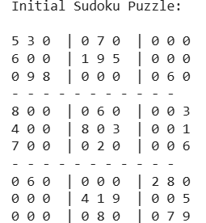

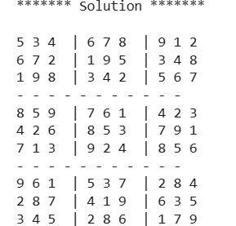  
———————————————————————————————

**Conclusion:**  
Constraint Satisfaction Problems provide a structured way to model and solve problems with multiple variables and constraints. Using techniques like backtracking and heuristics, CSP can efficiently find valid solutions while reducing unnecessary search.  
———————————————————————————————